**23CSE111**

**OBJECT ORIENTED PROGRAMMING**

**LAB REPORT**



**Department of Computer Science Engineering**

**Amrita School of Computing**

**Amrita Vishwa Vidyapeetham, Amaravati Campus**

**Name: N.Abhishek**

**Verified By Roll No: 24232**

|  |  |  |  |  |
| --- | --- | --- | --- | --- |
| **S.No.** | **Experiment Name** | **Page No.** | **Remarks** | **Signature** |
| 1 | Installation Process of JDK | 3 |  |  |
| 2 | Simple Java Program for printing basic details of student | 5 |  |  |
|  |  |  |  |  |
|  |  |  |  |  |
|  |  |  |  |  |
|  |  |  |  |  |
|  |  |  |  |  |

**WEEK-1**

**1) Explain the process of Installing JDK (Java Development Kit)**

**Installing of JDK (Java Development Kit):**

1. **Download JDK:**
   * Go to the Oracle JDK download page in your web browser and click on JDK-21 version which is Long term support (LTS) version.
   * Click on the download link for your operating system (Windows, macOS, or Linux).

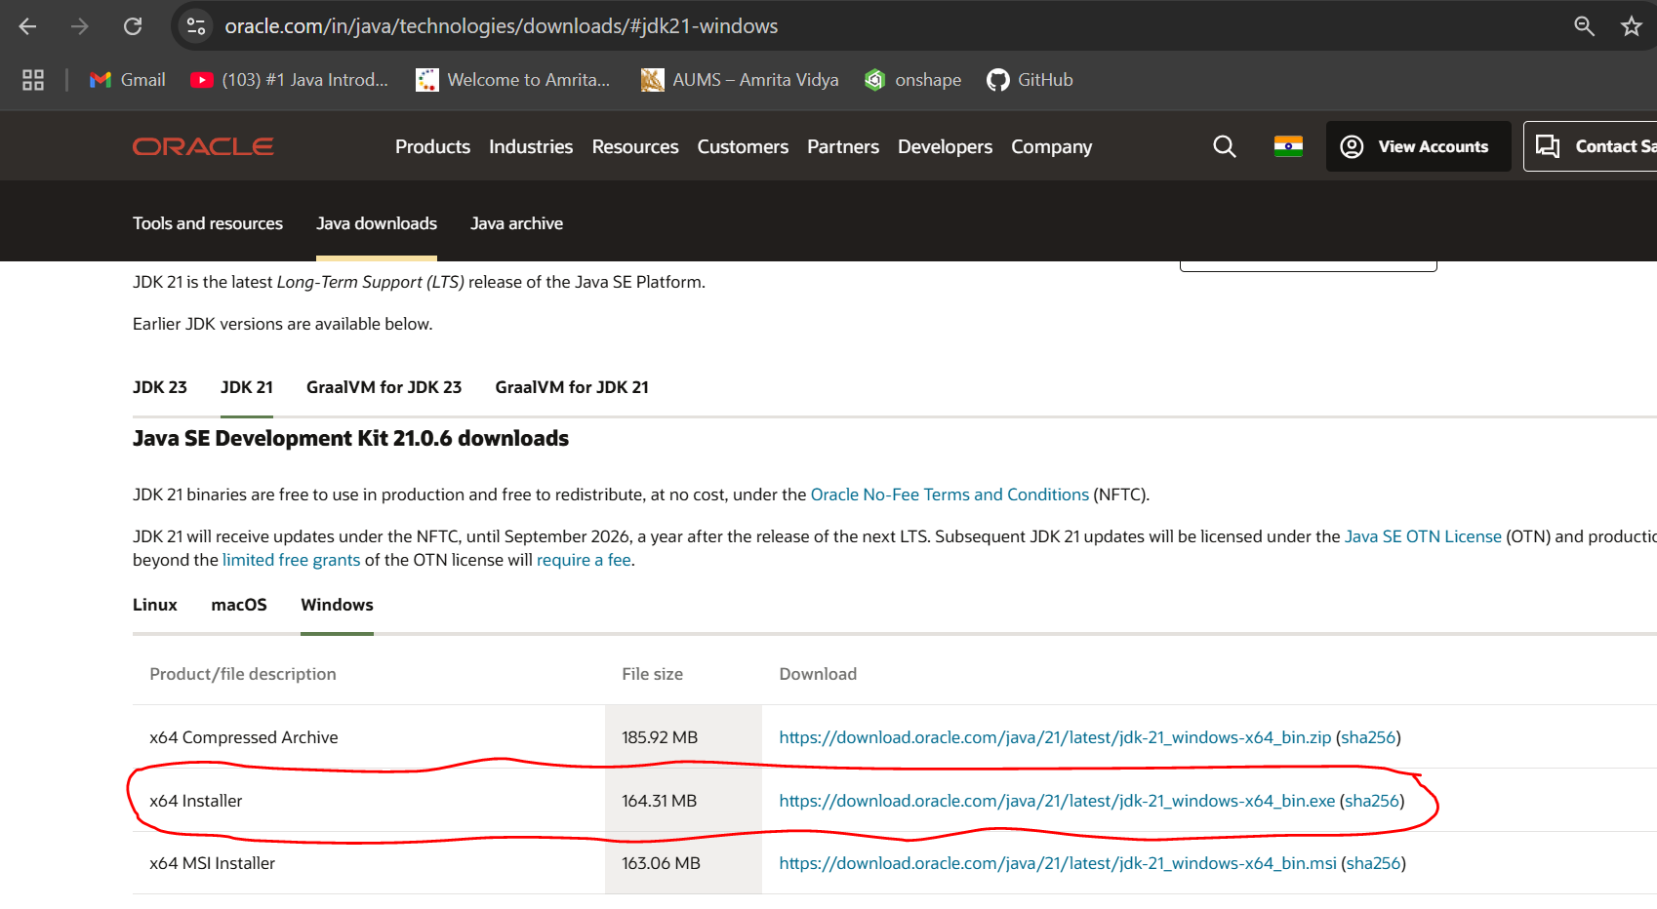

1. **Install JDK:**
   * Once downloaded, run the installer.
   * Follow the instructions and keep clicking "Next" until it's done.
2. **Set Environment Variables (Windows):**
   * For copying of path, go to c drive in file explorer
   * Then click on program files, in program files we can find the Java file click on it the in java file open bin file. Then click on the top of the file location then there we can select the file path location then copy it.
   * Open file explorer, then right click on This PC next select on properties then it will take you to the settings app then click on advanced system settings and then  
     click on **Environment Variables**.
   * Click **New** under **System Variables**:
     + **Set Variable name as:** java_home
     + **Variable value:** The folder address where JDK is installed (like C:\Program Files\Java\jdk-21\bin)
   * Find Path under **System Variables**, click **Edit**, and add the path of the jdk-21(C:\Program Files\Java\jdk-21\bin)  
       
       
       
     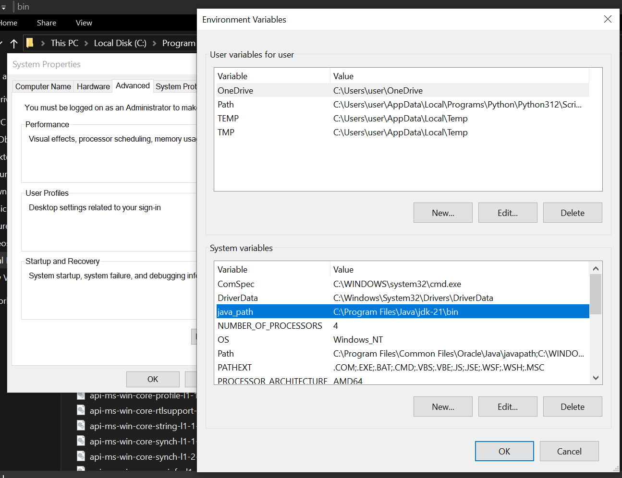

**Checking of JDK Version:**

1. **Open Command Prompt:**
   * Press win+R, type cmd, and press Enter.
2. **Check Version:**
   * Type java --version and press Enter.
   * Type javac --version and press Enter.

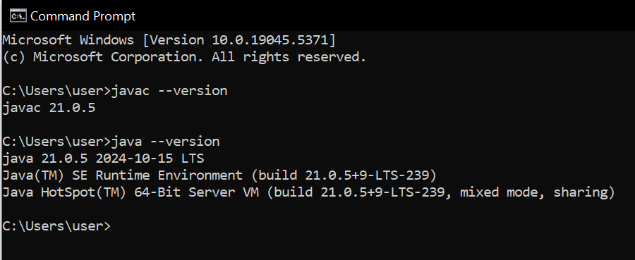

**2) Implement a Java Program to print basic details of a Student**

Write your code in Notepad and execute in cmd prompt

**Important Points:**

* + - * **Understand the syntax of a class.**

class Main {

public static void main(String[] args) {

System.out.println(" ");

}

}

**CODE:**

**The file was saved with Main.java**

class Main

{

public static void main(String[] args)

{

// Printing my basic details

System.out.println("Name:N.ABHISHEK");

System.out.println("Section: CSE-C");

System.out.println("Roll No : 24232");

}

}

**Output:**

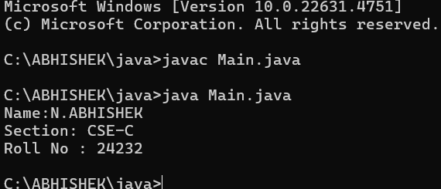

**Week 2**

1. **Simple Java Program for finding simple interest by taking input from**

**User**

**Code:**

**import java.util.Scanner;**

**public class Si {**

**public static void main(String[] args) {**

**Scanner scanner = new Scanner(System.in);**

**// Taking user inputs**

**System.out.print("Enter Principal amount: ");**

**double principal = scanner.nextDouble();**

**System.out.print("Enter Rate of Interest (per annum): ");**

**double rate = scanner.nextDouble();**

**System.out.print("Enter Time (in years): ");**

**double time = scanner.nextDouble();**

**// Calculate Simple Interest**

**double simpleInterest = (principal * rate * time) / 100;**

**// Display Output**

**System.out.println("Principal Amount: " + principal);**

**System.out.println("Rate of Interest: " + rate + "% per annum");**

**System.out.println("Time Period: " + time + " years");**

**System.out.println("Simple Interest: " + simpleInterest);**

**scanner.close();**

**}**

**}**

**Output**

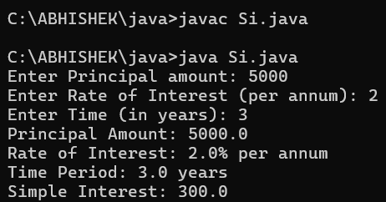

|  |  |  |  |
| --- | --- | --- | --- |
| **S.No** | **Error type** | **Reason for error** | **rectification** |
| **1** | **Syntax error** | **Did’nt declare variable type** | **Declared correct type** |
| **2** | **Syntax error** | **{ missing** | **{ added** |

**2.Write a simple program to calculate factorial of a number and read the**

**input from user**

**code:**

**import java.util.Scanner;**

**public class FactorialCalculator {**

**public static void main(String[] args) {**

**Scanner scanner = new Scanner(System.in);**

**System.out.print("Enter a number: ");**

**int number = scanner.nextInt();**

**long factorial = 1;**

**for (int i = 1; i <= number; i++) {**

**factorial *= i;**

**}**

**System.out.println("Factorial of " + number + " is: " + factorial);**

**scanner.close();**

**}**

**}**

**Output:**

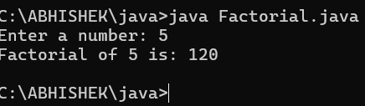

|  |  |  |  |
| --- | --- | --- | --- |
| **S.No** | **Error type** | **Reason for error** | **Rectification** |
| **1** | **Missing import statement** | **Not importing packages** | **Packages imported** |
| **2** | **Logical error** | **Wrong formula** | **Formula rectified** |

**3.Write a program to to calculate the fibonacii sequence and take the input from user**

**Code:**

**import java.util.*;**

**class fibo**

**{**

**public static void main(String args[])**

**{**

**Scanner sc = new Scanner(System.in);**

**int num;**

**int f3;**

**int f1 = 0;**

**int f2 = 1;**

**int i = 2;**

**System.out.print("Enter a number:");**

**num = sc.nextInt();**

**System.out.println(f1);**

**System.out.println(f2);**

**while(i<num)**

**{**

**f3 = f1+f2;**

**f1 = f2;**

**f2 = f3;**

**System.out.println(f3);**

**i = i+1;**

**}**

**}**

**}**

**Output:**

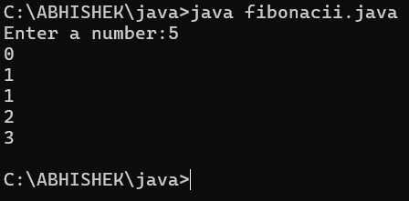

|  |  |  |  |
| --- | --- | --- | --- |
| **S.No** | **Error type** | **Reason for error** | **Rectification** |
| **1** | **Logical error** | **Incorrect formula** | **Formula rectified** |
| **2** | **Run-time error** | **Incorrect path** | **Added correct path** |

**Write a java program to convert temperature from Fahrenheit to celsius**

**Code:**

**import java.util.Scanner;**

**public class TemperatureConverter {**

**public static void main(String[] args) {**

**Scanner scanner = new Scanner(System.in);**

**System.out.print("Enter temperature in Fahrenheit: ");**

**double fahrenheit = scanner.nextDouble();**

**double celsius = (fahrenheit - 32) * 5 / 9;**

**System.out.println("Temperature in Celsius: " + celsius);**

**scanner.close();**

**}**

**}**

**Output:**

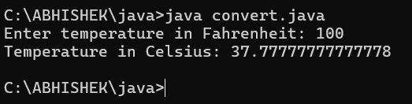

|  |  |  |  |
| --- | --- | --- | --- |
| **S.No** | **Error type** | **Reason for error** | **rectification** |
| **1** | **Syntax error** | **Missing ”** | **“ is added** |
| **2** | **Missing variable type** | **Didn’t declare variable** | **Declared variable** |

* 1. **Write a java program to convert temperature from Celsius to Fahrenheit**

**Code:**

**import java.util.Scanner;**

**public class convert {**

**public static void main(String[] args) {**

**Scanner scanner = new Scanner(System.in);**

**System.out.print("Enter temperature in Fahrenheit: ");**

**double fahrenheit = scanner.nextDouble();**

**double celsius = (fahrenheit - 32) * 5 / 9;**

**System.out.println("Temperature in Celsius: " + celsius);**

**scanner.close();**

**}**

**}**

**Output:**



|  |  |  |  |
| --- | --- | --- | --- |
| **S.No** | **Error type** | **Reason for error** | **Rectification** |
| **1** | **Runtime error** | **Incorrect path selection** | **Correct path added** |
| **2** | **Logical error** | **Incorrect logic** | **Correct logic** |

**Write a simple program to find the area of rectangle:**

**Code:**

**import java.util.Scanner;**

**public class Area {**

**public static void main(String[] args) {**

**Scanner scanner = new Scanner(System.in);**

**System.out.print("Enter the length of the rectangle: ");**

**double length = scanner.nextDouble();**

**System.out.print("Enter the width of the rectangle: ");**

**double width = scanner.nextDouble();**

**double area = length * width;**

**System.out.println("The area of the rectangle is: " + area);**

**scanner.close();**

**}**

**}**

**Output:**

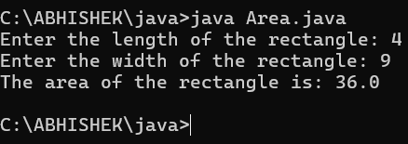

|  |  |  |  |
| --- | --- | --- | --- |
| **S.No** | **Error type** | **Reason for error** | **Rectification** |
| **1** | **Syntax error** | **Semi colon missing** | **Semi colon added** |
| **2** | **Missing import error** | **Import package missing** | **Import package added** |
| **3** |  |  |  |

**Write a program to find the area of triangle by using heron’s formula take the input from the user**

**Code:**

import java.util.Scanner;

public class TriangleAreaCalculator {

public static void main(String[] args) {

Scanner scanner = new Scanner(System.in);

System.out.print("Enter the first side of the triangle: ");

double a = scanner.nextDouble();

System.out.print("Enter the second side of the triangle: ");

double b = scanner.nextDouble();

System.out.print("Enter the third side of the triangle: ");

double c = scanner.nextDouble();

double s = (a + b + c) / 2;

double area = Math.sqrt(s * (s - a) * (s - b) * (s - c));

System.out.println("The area of the triangle is: " + area);

scanner.close();

}

}

**OUTPUT:**

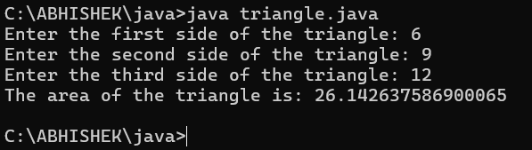

|  |  |  |  |
| --- | --- | --- | --- |
| **S.No** | **Error type** | **Reason for error** | **Rectification** |
| **1** | **Logical error** | **Incorrect formula** | **Formula rectified** |
| **2** | **Name error** | **Undeclared variable** | **Variable declared** |
|  |  |  |  |

WEEK – 3

1.Write a code for method attributes of a car for three objects.

Aim:writing java code using method attributes.

Code:

class car

{

public String car_color;

public String car_brand;

public String fuel_type;

public float mileage;

public void start()

{

System.out.println("Car starts");

}

public void stop()

{

System.out.println("Car stops");

}

public void service()

{

System.out.println("Car service");

}

public static void main(String [] args){

// object one creation

car car1= new car();

car1.car_color="Red";

car1.car_brand="BMW";

car1.fuel_type="Petrol";

car1.mileage=62.5F;

//calling methods for object 1

car1.start();

car1.stop();

car1.service();

System.out.println("color of the car1 is "+car1.car_color);

System.out.println("brand of the car1 is "+car1.car_brand);

System.out.println("fuel type of the car1 is "+car1.fuel_type);

System.out.println("mileage of the car1 is"+car1.mileage);

// object two creation

car car2= new car();

car2.car_color="Blue";

car2.car_brand="Audi";

car2.fuel_type="Petrol";

car2.mileage=64.5F;

// calling methods for object 2

car2.start();

car2.stop();

car2.service();

System.out.println("color of the car2 is "+car2.car_color);

System.out.println("brand of the car2 is "+car2.car_brand);

System.out.println("fuel type of the car2 is "+car2.fuel_type);

System.out.println("mileage of the car2 is"+car2.mileage);

//object three creation

car car3= new car();

car3.car_color="Yellow";

car3.car_brand="Benz";

car3.fuel_type="Diesel";

car3.mileage=66.5F;

// calling methods for object 3

car3.start();

car3.stop();

car3.service();

System.out.println("color of the car3 is "+car3.car_color);

System.out.println("brand of the car3 is "+car3.car_brand);

System.out.println("fuel type of the car3 is "+car3.fuel_type);

System.out.println("mileage of the car3 is"+car3.mileage);

}

}

OUTPUT:

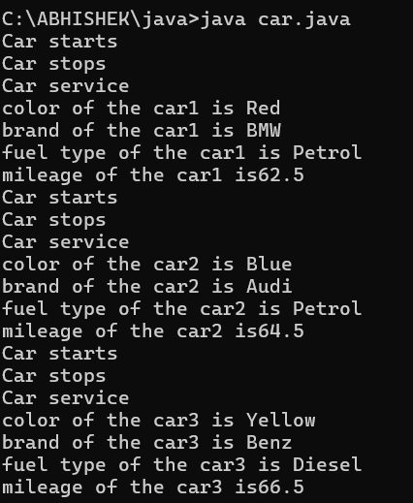

|  |  |  |  |
| --- | --- | --- | --- |
| Error type | Description | impact | Solution |
| Syntax error | Typo in the variable name mileage in the constructor | Compilation error ;  Constructor won’t work | Corrected to mileage |
| Mthod signature | Getter methods color,brand,fuel,mile had parameters but were expected to return instance values | Causes incorrect behaviour when  Calling methods | Removed parameters from method definition |

CLASS DIAGRAM :

|  |
| --- |
| Main |
| -car_color:string  -car_brand: string  - fuel_type:string  -mileage:int |
| +color():String  +brand():String  +fuel():String  +mile():int |

Aim:writing a java code for the bank account details

Code:

class Bank_Account {

private String accname;

private int acno;

private float balance;

public Bank_Account(String accname, int acno, float balance) {

this.accname = accname;

this.acno = acno;

this.balance = balance;

}

public void withdraw(int amount) {

if (amount <= balance) {

balance -= amount;

System.out.println("Withdrawal of " + amount + " successful. Remaining balance: " + balance);

} else {

System.out.println("Insufficient balance for " + accname);

}

}

public void deposit(int amount) {

balance += amount;

System.out.println("Deposit of " + amount + " successful. Updated balance: " + balance);

}

public void displayDetails() {

System.out.println("Account Name: " + accname);

System.out.println("Account Number: " + acno);

System.out.println("Balance: " + balance);

}

public static void main(String[] args) {

Bank_Account s = new Bank_Account("Anil", 34571, 25000);

s.withdraw(20000);

s.deposit(2000);

s.displayDetails();

System.out.println();

Bank_Account s1 = new Bank_Account("Jeevan", 333226, 25000);

s1.withdraw(2500);

s1.deposit(250000);

s1.displayDetails();

}

}

Output:

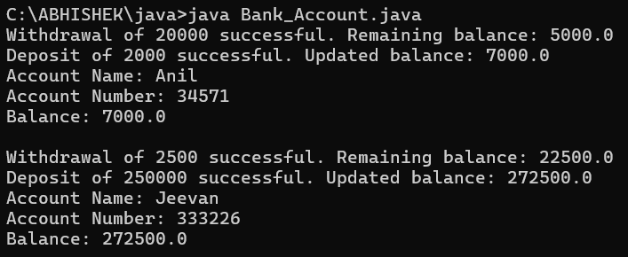

|  |  |  |  |
| --- | --- | --- | --- |
| Error type | subscription | Impact | Solution |
| Missing balance dispaly | Withdraw and deposit methods update the balance but not dispaly | User cannot see the current balance after transactions | Add system.out.println on both methods |
| No getter methods | No method to retrieve account details | Cannot account details outside of the class | Add getter methods like getBalance(), getAccName(), etc. |

CLASS DIAGRAM:

|  |
| --- |
| Bank_Account |
| -accname:String  -acno:int  -balance:float |
| +withdraw(amount:int):void  +deposit(amount:int):void  +displaydetails():void |

WEEK 4:

LAB 4:

1.AIM: WRITE A JAVA PROGRAM WITH CLASS NAMED “Book”. THE CLASS SHOUKD CONTAIN VARIOUS ATTRIBUTES SUCH AS TITLE, AUTHOR, YEAR OF PUBLICATION. IT SHOULD ALSO CONTAIN A CONSTRUCTOR WITH PARAMETERS WHICH INITIALIZES TITLE, AUTHOR, YEAR OF PUBLICATION AND CREATE A METHOD WHICH DISPLAYS THE DETAILS OF 2 BOOKS.

CODE:

public class Book {

public String title;

public String author;

public int year;

Book(String title, String author, int year) {

this.title = title;

this.author = author;

this.year = year;

}

public void displayDetails() {

System.out.println("Title: " +title);

System.out.println("Author: " +author);

System.out.println("Year of Publication" +year);

}

public static void main(String[] args) {

Book b1 = new Book("Math", "Ramanujan", 1950);

Book b2 = new Book("Physics", "CV Raman", 1960);

b1.displayDetails();

b2.displayDetails();

}

}

OUTPUT:

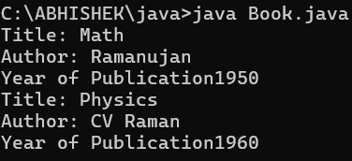

|  |  |  |  |
| --- | --- | --- | --- |
| ERROR TYPE | DESCRIPTION | IMPACT | SOLUTION |
| Compilation error | Missing semicolon | Code will not compile | Add semicolons at the end of the lines |
| Logical error | Missing spacing in the print statements | Output may be concatenated improperly | Add a space after year of publication in the display details () method |

CLASS DIAGRAM:

|  |
| --- |
| Book |
| - title: String  - author: String  - year: int |
| Book(String, String, int)  + displayDetails(): void |

2. AIM: WRITE A JAVA PROGRAM WITH CLASS NAMED “MyClass” WITH A STATIC VARIABLE COUNT OF INT TYPE. INTIALIZE IT TO ZERO AND A CONSTANT VARIABLE “Pi” OF TYPE DOUBLE INITIALIZED TO “3.14” AS ATTRIBUTES OF THAT CLASS. NOW DEFINE A CONSTRUCTOR FOR “MyClass”, THAT INCREMENTS THE COUNT VARIABLE EACH TIME AN OBJECT OF “MyClass” IS CREATED. FINALLY, PRINT THE FINAL VALUES OF ‘COUNT’ AND ‘PI’ VARIABLES AND CREATE 3 OBJECTS.

CODE:

public class MyClass {

static int count = 0;

static final double pi = 3.14;

MyClass() {

count++;

}

public static void main(String[] args) {

MyClass obj1 = new MyClass();

MyClass obj2 = new MyClass();

MyClass obj3 = new MyClass();

System.out.println("Count: " +count);

System.out.println("Pi: " +pi);

}

}

OUTPUT:

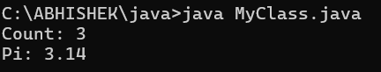

|  |  |  |  |
| --- | --- | --- | --- |
| Error type | Description | Impact | Solution |
| Logical error | Missing space in the println statement for count and pi | Output may be concatenated improperly. | Add a space before +count and+pi in the println statement. |

CLASS DIAGRAM:

|  |
| --- |
| MyClass |
| - count: int (static)  - pi: double (static final) |
| + MyClass()  + main(String[] args): void |